1. Total sales per product.

db.sales.aggregate([{$group:{_id:"$product",totalSales:{$sum:{$multiply:["$price","$quantity"]}}}}])

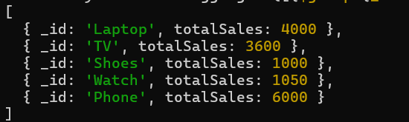

1. Total revenue per product.

db.sales.aggregate([{$group:{_id:"$product",totalRevenue:{$sum:{$multiply:["$price","$quantity"]}}}}])

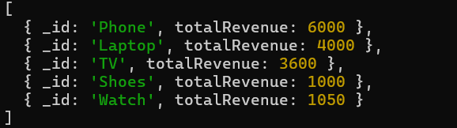

1. Total revenue per category.

db.sales.aggregate([{$group:{_id:"$category",totalRevenue:{$sum:{$multiply:["$price","$quantity"]}}}}])

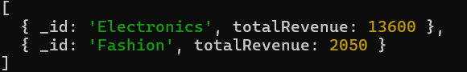

1. Count of products per category.

db.sales.aggregate([{$group:{_id:"$category",count:{$sum:1}}}])



1. Store-wise total sales.

db.sales.aggregate([{$group:{_id:"$store",totalSales:{$sum:{$multiply:["$price","$quantity"]}}}}])

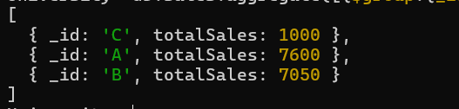

1. Average price of products per category.

db.sales.aggregate([{$group:{_id:"$category",avgPrice:{$avg:"$price"}}}])

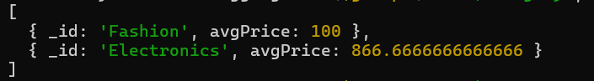

1. Top-selling product.

db.sales.aggregate([{$group:{_id:"$product",totalSales:{$sum:"$quantity"}}},{$sort:{totalSales:-1}},{$limit:1}])



1. Total sales for Electronics category.

db.sales.aggregate([{$match:{category:"Electronics"}},{$group:{_id:"Electronics",totalSales:{$sum:{$multiply:["$price","$quantity"]}}}}])



1. Sales trend over time (day-wise total sales).

db.sales.aggregate([{$group:{_id:{$dateToString:{format:"%Y-%m-%d",date:"$date"}},totalSales:{$sum:{$multiply:["$price","$quantity"]}}}}])

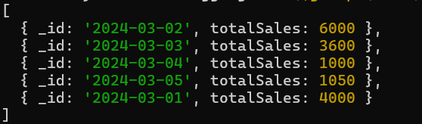

1. Highest revenue-generating product.

db.sales.aggregate([{$group:{_id:"$product",totalRevenue:{$sum:{$multiply:["$price","$quantity"]}}}},{$sort:{totalRevenue:-1}},{$limit:1}])



1. Average revenue per sale.

db.sales.aggregate([{$project:{sales:{$multiply:["$price","$quantity"]}}},{$group:{_id:"category",avgSales:{$avg:"$sales"}}}])



1. Sales performance per store.

db.sales.aggregate([{$group:{_id:"$store",totalSales:{$sum:{$multiply:["$price","$quantity"]}}}}])

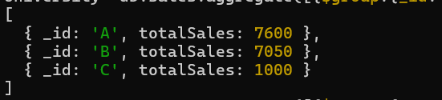

1. Products sold more than 5 times.

db.sales.aggregate([{$group:{_id:"$product",totalSales:{$sum:"$quantity"}}},{$match:{totalSales:{$gt:5}}}])

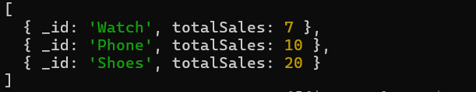

1. Least sold product.

db.sales.aggregate([{$group:{_id:"$product",totalSales:{$sum:"$quantity"}}},{$sort:{totalSales:1}},{$limit:1}])



1. Monthly sales summary.

db.sales.aggregate([{$group:{_id:{$dateToString:{format:"%Y-%m",date:"$date"}},totalSales:{$sum:{$multiply:["$price","$quantity"]}}}}])



1. Number of unique products sold.

db.sales.aggregate([{$group:{_id:"product",uniqueProducts:{$addToSet:"$product"}}},{$project:{uniqueProducts:{$size:"$uniqueProducts"}}}])



1. Maximum and minimum priced product.

db.sales.aggregate([{$group:{_id:"price",maxPrice:{$max:"$price"},minPrice:{$min:"$price"}}}])



1. Total revenue per product in descending order.

db.sales.aggregate([{$group:{_id:"$product",totalRevenue:{$sum:{$multiply:["$price","$quantity"]}}}},{$sort:{totalRevenue:-1}}])

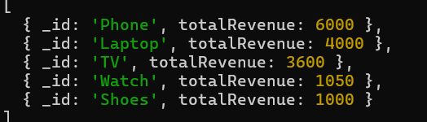

1. Revenue generated per store per category.

db.sales.aggregate([{$group:{_id:{store:"$store",category:"$category"},totalRevenue:{$sum:{$multiply:["$price","$quantity"]}}}}])

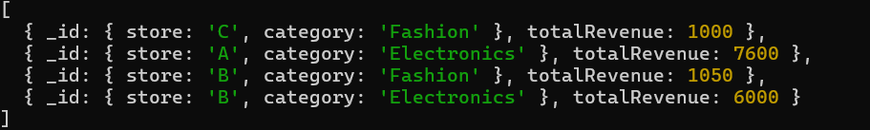

1. Products contributing more than 50% revenue.

db.sales.aggregate([{$group:{_id:"$product",totalRevenue:{$sum:{$multiply:["$price","$quantity"]}}}},{$match:{totalRevennue:{$gt:{$multiply:["$totalRevenue",0.5]}}}}])

